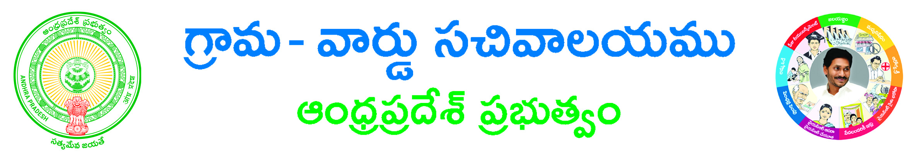
FORM – I
FORM OF APPLICATION FOR ISSUE OF COMMUNITY, NATIVITY AND DATE OF BIRTH CERTIFICATE RELATING TO SOCIALY AND EDUCATIONALY BACKWARD CLASSES OF MUSLIMS
(Information to be furnished by the applicant himself supported by documentary evidence)
To
The Tahsildar
………………………..
……………………….District.
Sir
I am in need of Backward Class Community Certificate for my Son/Daughter/ ……………………………………………. For which the details are give below.
1. Name of the Applicant in full (in Block Letters) | :
2. Sex of the Applicant | :
3. a) Father’s Name | :
b) Mother’s Name | :
4. Present Postal Address | : | D.No: Locality:  Village: Mandal:  District: Pincode:
5. Permanent Place of Residence | : | D.No: Locality:  Village: Mandal:  District: Pincode:
6. Age, Date of Birth and Place of Birth (if date is  not known approx, Year of Birth) | :
7. Place of ordinary Residence Documents related  to house/Land or other immovable property or  Birth Registration Certificates or Ration Card or  School records may be furnished | :
8. If the applicant has been issued a Community  Certificate in the past by any authority, a copy  of such Certificate should be furnished. | :
9. Community for which certificate is claimed  (including Group, Sub-Group) | :
10. Religion professed by the father of the  Applicant | :
11. (a) Religion professed by the Father of the  Applicant | :
(b) Religion professed by the mother of the  Applicant. | :
12. Ration card Number | :
13. Aadhaar Number | :
14. Mobile | :
15. Phone | :
16. Email | :

(PTO)

::2::

17 (a) Class/Community/ Group (including sub-group) of the father__________________
(b) Class/ Community Group(including sub-group) of the father___________________

18. if to be included under other Muslim groups under Item No.15 of G.O.Ms,. No.23 Backward Classes Welfare (C2) Department, dated 7th July, 2007.

I hereby declare that I belongs to other Muslim groups excluding Syed, Saiyed, Sayyed, Mushaik, Mughal, Moghal; Pathans: Iranl; Arab; Bohare: Bohara: Shia Imami ismail, Khoja, Cutchi-Memon; Jamayat; Navayat, and all the synonyms and sub-groups of the excluded groups; and except those who have been already included in the State list of Backward Classes.

19. Whether the Applicant is

- A natural born Son/Daughter of his/her parents ____________________________
OR
- Not

DECLARATION

I/We declare that the information furnished by me / us in the application is true and correct, and the documents appended thereto are genuine and the contents of the documents are true and correct and that if these are found to be untrue and incorrect, I/We will be liable for prosecution for furnishing false and incorrect information/ documents under section 10 of the Act No.16 of 1993.

Station: Signature of the Applicant.
Date :

Signature of the Parent/Guardian

Enclosures:
1. Application Form*
2. Caste Certificate issued to the family members#
3. SSC marks memo or DOB extract or Transfer certificate#
4. 1 TO 10th study certificate or DOB certificates issued by Municipality/Gram Panchayath#
5. Ration Card/EPIC Card /AADHAR CARD#
6. Schedule I to IV #

(*-mandatory #-any one of them)

